**Los Padres Communication Center**

**COVID-19 In-Briefing**

Welcome to Los Padres Communication Center! Due to the COVID-19 pandemic, we have had to apply some new business practices that will help you and your fellow coworkers create a clean and healthy work environment. Listed below is the Los Padres Communications Center, COVID-19, workspace policies that are currently in place for employee health and safety precautions:

**To assist, we are asking all visitors to self-assess using the following USDA provided questions:**

1. *In the last 14 days have you had a fever greater than 100.4o, shortness of breath, body-aches or coughing (not attributable to allergies) or been diagnosed with COVID-19 (presumptive or positive test)?*
   * *If so, do not return to work until cleared by a medical professional or you meet CDC guidance on “*[*Discontinuation of Isolation*](https://www.cdc.gov/coronavirus/2019-ncov/hcp/disposition-in-home-patients.html)*.”*
2. *In the last 14 days have you had close contact with someone who may have COVID-19? This includes anyone with a positive COVID-19 test or who has COVID-19 symptoms (fever greater than 100.4o, shortness of breath, body-aches or coughing (not attributable to allergies)).*
   * *If so,* *you cannot report to the workplace until cleared by a medical provider or until 14 days after the last date of exposure. If you develop symptoms, see #1.*
3. *In the last 14 days have you assisted in the care of an individual (outside your household) who is not well?* 
   * *If so and you were wearing proper PPE (including a N95 mask), work with your supervisor to determine whether you should report to the workplace.*
   * *If so and you were not wearing proper PPE,* *you cannot report to the workplace until cleared by a medical provider or until 14 days after date of exposure. If you develop symptoms, see #1.*
4. *In the last 14 days have you returned from another country or high-risk area? The local unit has discretion on how to define high-risk based on current conditions.* 
   * *If so, you cannot report to the workplace until cleared by a medical provider or until 14 days after return. If you develop symptoms, see #1.*

**If you answer ‘no’ to all the listed questions, please call the following number for assistance in obtaining entrance to the office. This may include setting up an appointment to enhance social distancing and minimize the number of visitors in our office at one time.**

805-938-9142 X0 (Business Hours, 07:30- 18:30)

**If you answer ‘yes’ to any of the listed questions and you are capable, we request that you notify the LPCC at the above number.**

With the COVID-19 pandemic in full swing, it is important for all of us to take certain precautions to maintain a healthy workforce. This briefing has been designed to outline the precautions and guidelines that must be adhered too daily during your assignment at the LPCC.

* Work shift transitions will take place with no more than 2 people arriving and 2 people departing at the same time to minimize the number of personnel at any one given time in the ECC.
* Prior to the start of shift, ensure that your workspace has been wiped down and sanitized, to include desktops and counters, phones, copy machines, doorknobs, keyboards pens, staplers, etc. Before leaving in the evening, repeat the process and ensure your workspace has been sanitized.
* Rotating positions is discouraged but in the event it occurs, make sure that workspaces are re-sanitized as soon as possible. An example would be, if the ACDP steps out for lunch and there’s a response while he/she is in out and you need to take over, make sure to sanitize the workspace before the ACDP returns to their position.
* Above sanitizing your workspace each day, all employees will help clean and sanitize the ECC interior to include, wiping down the refrigerator, light switches, counter space, cabinets, kitchen table, etc. This should occur on a rotational basis and realistically you will likely be asked to do so, every 3 or 4 days but it is important that we all do our part.
* Washing your hands several times throughout the day is encouraged. CDC guidelines state that handwashing is most effective when is occurs for at least 20 seconds.

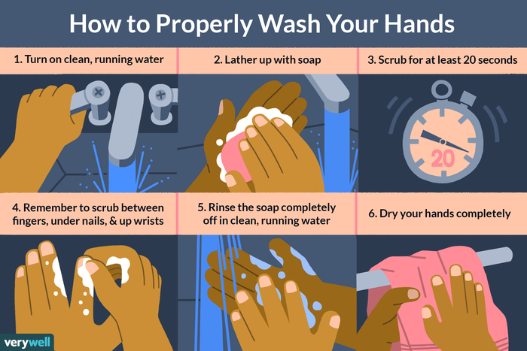

* Currently, it is employee discretion if you want to wear a mask. Due to a nationwide shortage, the LPCC cannot provide masks but can direct you on where to find instructions to construct your own or you may acquire masks from an outside source.
* If circumstances arise that require you to travel in an agency owned vehicle, where you are not the sole passenger, ie trips to fire camp, IMT briefings, incident close-outs, etc., then the LPCC will provide you with a mask.
* Employees will be required to monitor their temperatures prior to their workday and throughout the day. Employees will be expected to leave the ECC and self-quarantine should they experience an inner-body core temp in excess of 100.4 or experience any flu-like symptoms. There will be No-Touch, forehead thermometers available at the LPCC.
* Please do not bring more than a day’s worth of food with you during any given shift and if you need to utilize dishes, please wash them immediately after use and place them into the dishwasher for a follow-up cleaning.
* In order to maintain CDC guidelines for social distancing, the maximum number of personnel allowed into Expanded at any given time will not exceed 6. Should we meet capacity, the identified positions that will be occupied are; Supplies, Equipment #3, Crews, Overhead #2, and Supervisor #1 and #2.
* Staffing of the Initial Attack Floor will be limited to 4 personnel at any given time and consist of the following positions; IA, Aircraft, Law Enforcement and Call Taker positions.
* Due to the present situation, community meals/snacks, food sharing or group barbeques will not be allowed. Bring only what you need for the day or food delivery or pick-up is also acceptable.

